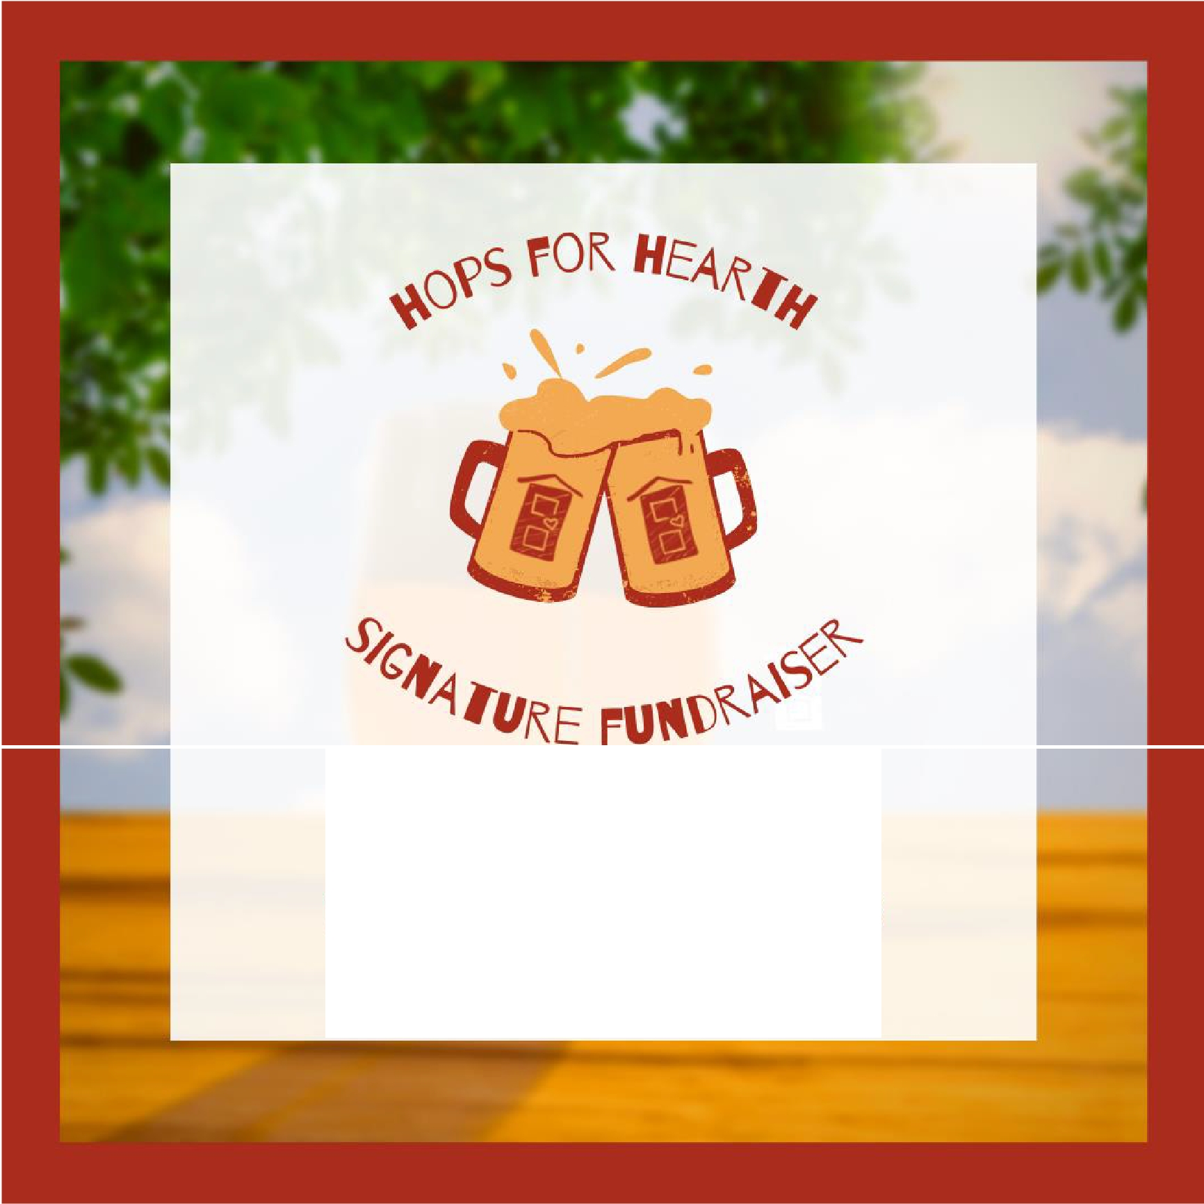

**FRIDAY, APRIL 1, 2022**

**NOVA PLACE 100 S COMMONS**

**PITTSBURGH, PA 15212**

SPONSORSHIP OPPORTUNITIES FOR 2022

**Vision:** Every family and individual lives in safe, affordable housing.

**Mission:** To provide a range of supportive services and housing that empowers homeless families, who are survivors of domestic violence or other trauma to become independent, self-sufficient, and adequately housed; to foster housing opportunities to prevent homelessness and encourage safe, affordable housing.

**HEARTH**

3724 Mt. Royal Blvd. Suite 101

Glenshaw, PA 15116

(412) 366-9801

*If you are interested in sponsoring this event or learning more on how to get involved, please check out our website at* [*www.hearthpgh.org*](https://hearthpgh.org/)

*reach out to Jennifer Lawrence at* [*Events@hearthpgh.org*](mailto:Events@hearthpgh.org) *or 412-298-1045*

|  |  |
| --- | --- |
|  | •  •  •  •  •  •  •  •  •  •  • |
|  | •  •  •  •  •  • |
|  | •  •  •  •  • |
|  | •  •  •  •  • |

